Shawn Chen

2017003399

FXV interface re-design

**An explanation of your design decisions and how they affect a user's interaction with the application.**

Adjustments:

1. **Main Navigation**

* **Icons on navigation bar**

The icons is an type of GUI element used to represent the function on each button. However, there are some problems in current design regarding to the usage of icons, that some icons does not really indicate users what they can do, what will happened after click, or even does not represent the function of button. So, there are some new icons applied in the new design for this application.

**Leaderboards button on main navigation bar:**



The old icon used for leaderboards button dose not clearly represent to users that the button means to be leaderboard. It will cause users confused with page design and difficult to navigate.



New design for the Leaderboards page will indicate users that they could see the information about scores and ranks, which Leaderboards page aims for.

**Tests button on main navigation bar:**



The old icon used normally represents common exercise which is not quite suitable for the purpose of fitness tests.



The new icon is strongly related with fitness or gym, which could indicate users to obtain information regarding to the fitness tests.

**Combine button on main navigation bar:**



The icon used for current system is more likely to be suitable in terms of tasks, or missions, which is not appropriate for the purpose that the icon needs to indicate users the function that to lead user to the combined fitness tests page.



This icon is normally used to indicate assessments for students, as the same concept of “Combine” which is combined multiple fitness tests, like a set of assignment for athletes.

* **Main navigation bar**

The new design does not change the main navigation bar, as it was well designed to deliver a great user experience and indicate users with possibility of accessibility of each elements on main navigation bar.

The navigation bar has 2 status switched by a little arrow on top: Extended status & Collapsed status.

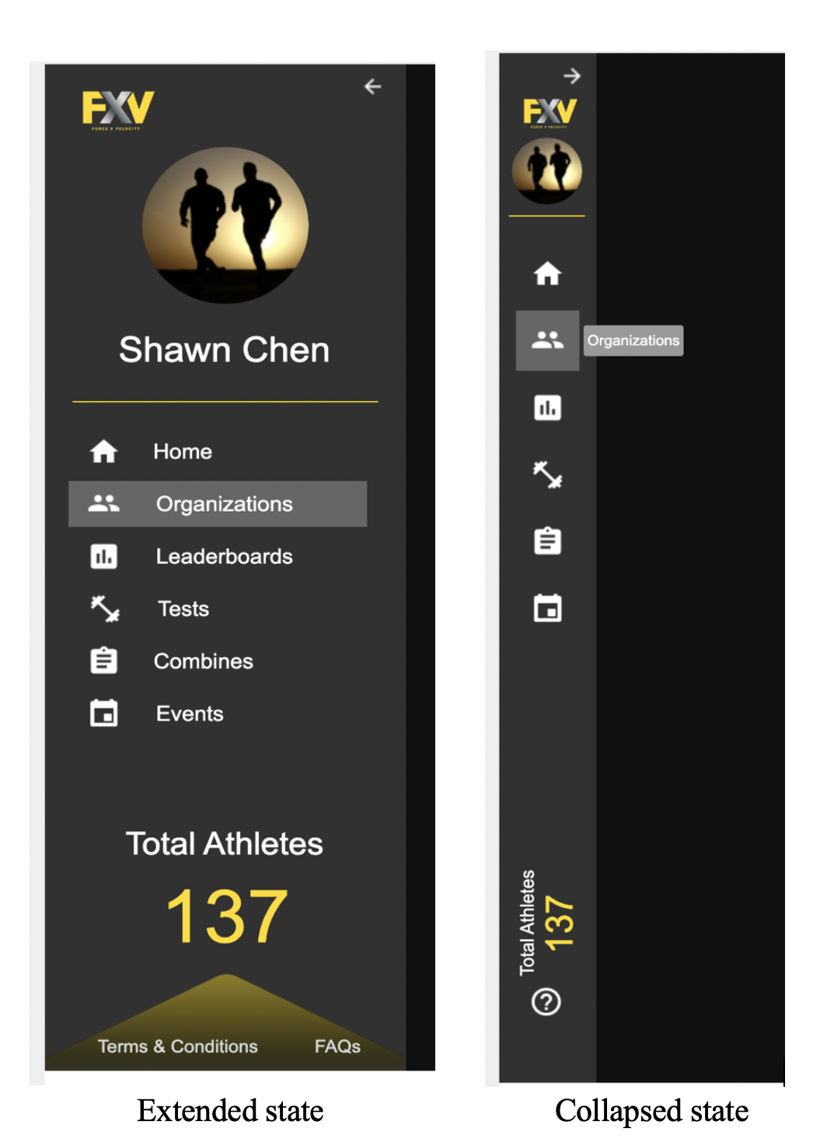

As can be seen through the screenshot of navigation under the different status,

The main navigation bar under the extended status, is wider with full content for the function on each navigation button, and will be highlighted when mouse over it to give users better feedbacks and indicate users the possibility of accessibility to a relevant page.

The main navigation bar under the collapsed status is less width, in order to provide more space for the main content area. And also because of the width of navigation area is limited, so the content/function for each button was removed and replace by using notification block to indicate users the possibility of accessibility to a relevant page, when the mouse is over it. This could also increase the user experience as user do not need to remember what function for each button as the icons could be helpful, and if user still do not understand, the notification block will be helpful as well.

In addition, both navigation design will be always fixed on left side of page, which provides convenience to users that they could switch pages easily no matter which position of the page, the user is currently at.

1. **Organization information page**

There are 3 sections on the organization information page divided by section titles with large font size to help to build a better visual hierarchy, the sections includes organization details, teams, and organization members. This page is designed to provide organization manager, team manager or administrator with appropriate information. all of those 3 sections have problems regarding to “a good UI design”.

**First section: Organization basic detail**

Problems:

There are no sufficient information supported for users to better understand the organization which is not the purpose of the page initially designed, as there are only organization image, organization name, short description, location and manager name provided.

Solutions:

The new design contains more organization information than initially provided, including the numbers of overall members and overall teams, these information could be really important for organization manager, and also could show the scale of this organization, to make them more competitive.

**Second section: Teams**

Problems:

In the current system, if user click any team, there will be a pop up panel which is used to display further information of a specific team. This design could easily confuse user that the primary action of this clickable tag is supposed to direct user to team page rather than a pop up panel appeared. Also, there is no indication for the purpose of to deliver perception to users or to make users feel directly manipulating with the system, as user might do not even know each of team tag can be clicked without an indication.

Solutions:

The new design of this section, the pop up panel is disused and those necessary information originally on pop up panel, are assigned on each team tag.

A new html style used to highlight particular team tag when mouse is over it, in order to providing a better user experience that users always receive the feedback, also to indicate users the possibility of accessibility on each tag that tags are clickable and could lead users to a relevant page.

In additional, the focus of this section is not just to see the list of teams, also to find the specific one for more further information. As the result, a search box is made in this section for the purpose of searching a team or teams via a team name rather than scrolling till the team been found, this could increase the user experience as well.

On top of those changes, all team tags is varied from horizontal direction to vertical direction, which could be much more clean than having 3 team tags on each row.

**Third section: All members**

Problems:

The current design is to display all user details on this section, which is not the purpose of this section on the organization information page. The idea to have this section is to enable administrator, organization manager, and team manager to see athletes and managers under them control. Apart of this, the focus of this area should be more related to the structure of organization and team and useful data of fitness, instead of their basic detail like, address, city, email, mobile, etc. Also, there is no indication to deliver perception to users or to make users feel directly manipulating with the system.

Solutions:

The new design has removed useless information for this section to provide only useful information which target users expected, including members' image, name, gender, age, position/role and team, and a search box applied in this section for better user experience.

Then, same as the solution for user indication on the second section that a new html style applied to highlight particular member tag when mouse is over it, in order to providing a better user experience that users always receive the feedback, also to indicate users the possibility of accessibility on each tag that tags are clickable and could lead users to a relevant page.

Also, the coloured icon used for gender could be more helpful and efficient for user to obtain information as the coloured icon for gender is easily recognized nowadays, rather than read through normal content which is widely used for everywhere and our target users might be visual fatigued by always reading contents.

In additional, the coloured age content could be useful to represent different age group, which is really important for the roles such as coach and team manager, as they need to understand the age group for the purpose of athlete training.

Examples of colours used for age group could be:

1. Green represents youger athletes as green usually indicates growth and hope.
2. Red represents the best age group for athlete, as red usually means the energy, strength, and power.

Reference: <http://www.color-wheel-pro.com/color-meaning.html>

**3. Organization team information page**

There are 2 sections on the organization team information page divided by section titles with large font size to help to build a better visual hierarchy, the sections includes organization team details, and team members. This page is designed to provide organization manager, team manager or administrator with appropriate information. Both 2 sections have problems with “the good UI design”.

**First section: Organization team basic detail**

Problems:

Same problems as found on the current organization information page that there are no sufficient information supported for users to better understand the team which is not the purpose of the page initially designed, as there are only with only team image, team name, short description, location and manager name provided.

Solutions:

So, the same solution applied as what has been done for the new design on organization information that adding an element to display the numbers of overall members, which could be really useful for understanding the scale of the team.

**Second section: All members**

Problems:

As same as on the teams section on organization information page that there will be a pop up panel to display further athlete information which actually could be combined on the athlete tag.

Solutions:

The new design has removed the pop up panel and assigned some necessary information on each of athlete tag on the team information page in order to avoid the wrong primary action of each member tag, which is supposed to lead user to athlete profile page directly as the new design on the organization information page.

A search box also applied in this section to a better user experience as mentioned on the organization information page, and a highlighted html style will be used for member tag when mouse is over it to indicate users the tags are clickable as same as the adjustment on organization information page.

Then, the coloured elements have significantly used for this section to deliver some important information, including:

1. The use of the coloured gender icon applied for easier recognizing gender instead of reading through content.
2. The coloured age content to represent different age group.
3. A dark colour used for the position title which aims to highlight the value of the position as the position is one of the main focus on each of athlete tag displayed on all members tag.

On top of those changes, all members tag displayed has varied from horizontal direction to vertical direction which could be much more clean than put 3 member tags on each row.

**3. User profile page**

Problems:

Form the original design of this application, the profile page is used for the promotional purpose of athletes with fitness statistics. However, the current UI design shows that there is no sufficient information provided to promote athlete with only basic information of athlete themselves. also, the "combine score" is not really clear that no one knows what tests included and how is performance of the athlete based on score represented.

Solutions:

In the new design, there are a lot of useful information has added on the profile page that could be really helpful to promote athletes themselves, including:

* Athlete image
* Extra basic information (like nationality and current location)
* The biology statistics which could be really useful for coach to predict the performance of the athlete (like height, weight, standing reach, wingspan, handspan, and dominant hand)
* The detailed score section with combine name, an icon representing the action which could display a full list of tests belonging to the combine after mouse is over the icon, the athlete best score, rank, and what is the top score in this combined test
* A re-designed organizations and teams section as they are always related instead of put them separately as originally designed, and the organization name will be used as the header of teams within the same organization which could help to build a great visual hierarchy.

For the biology part, the opposite position of the header and value in the new design could help to make those important biological value more prominent.

On the other hand, the coloured gender icon and coloured age content also applied on this page as well, (the advantages of using those element has been explain on above).

The FXV yellow used to highlight the value of combined tests also indicate users that those combined testing and calculation system are owned by FXV which shows the uniqueness and compatibility.

In additional, the edit button has been moved below the athlete image as most application designed, which most users would be more familiar with.

**Supporting data that informed design decisions**

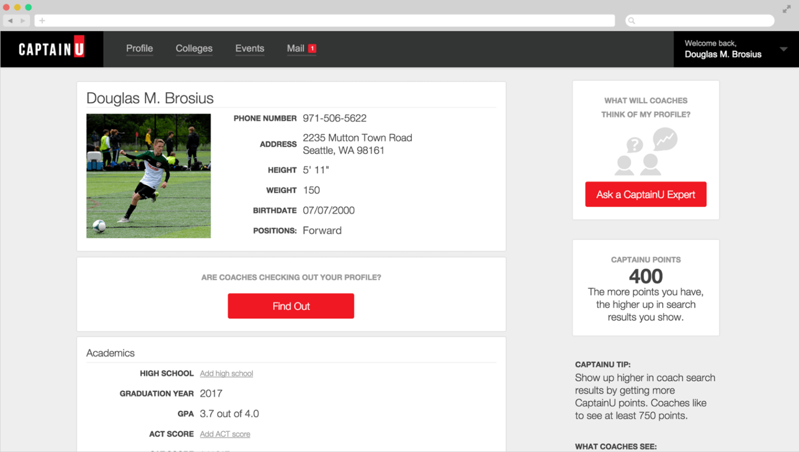

The information on profile page was inspired by a web application called CaptainU, especially the biology part, which is actually really important for athletes to promote themselves and teams to hire athletes, because all those important biological statistics could be useful to predict if the athlete is appropriate for this team position or not.

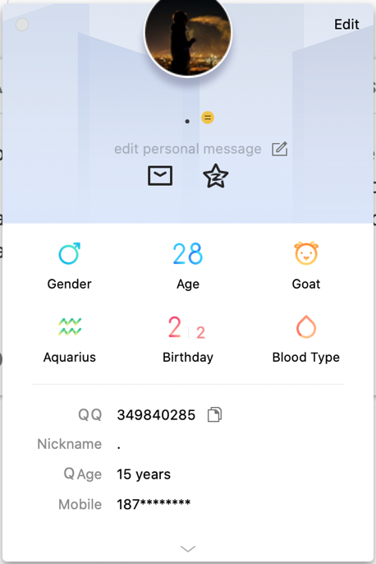

The coloured gender icon and coloured age were inspired by a Chinese messaging app called QQ, and also the opposite way of using header and value does help to extract the key information form the entire page.

**Use case diagrams**



Use case diagram for administrators



Use case diagram for other types of users

**Prototype images**



**Main navigation bar**

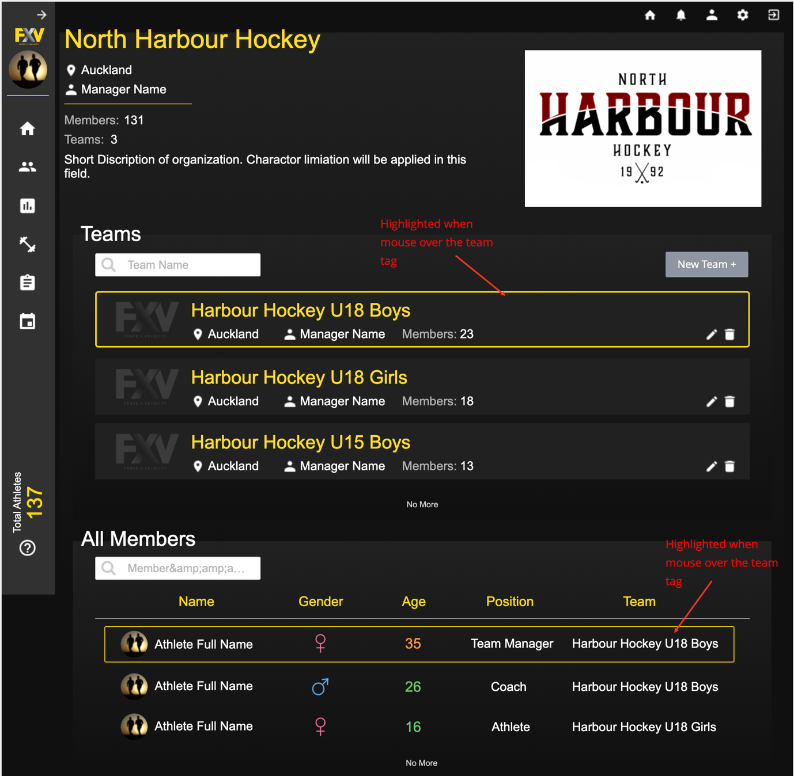

**Organization information page**

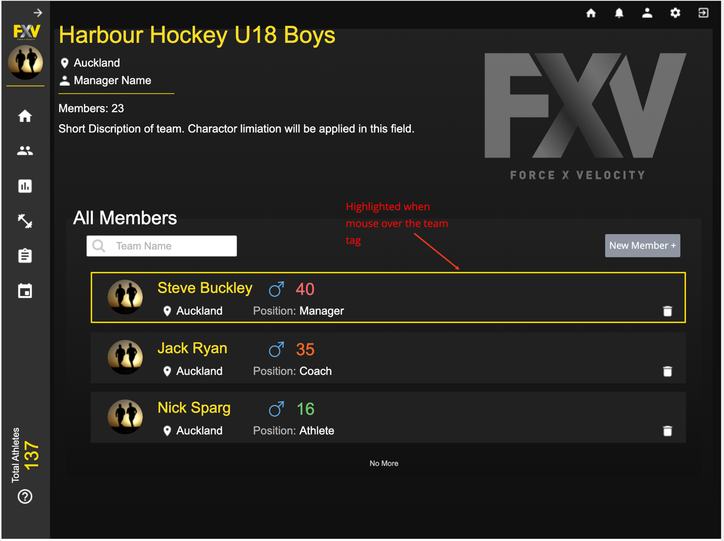

**Organization team information page**

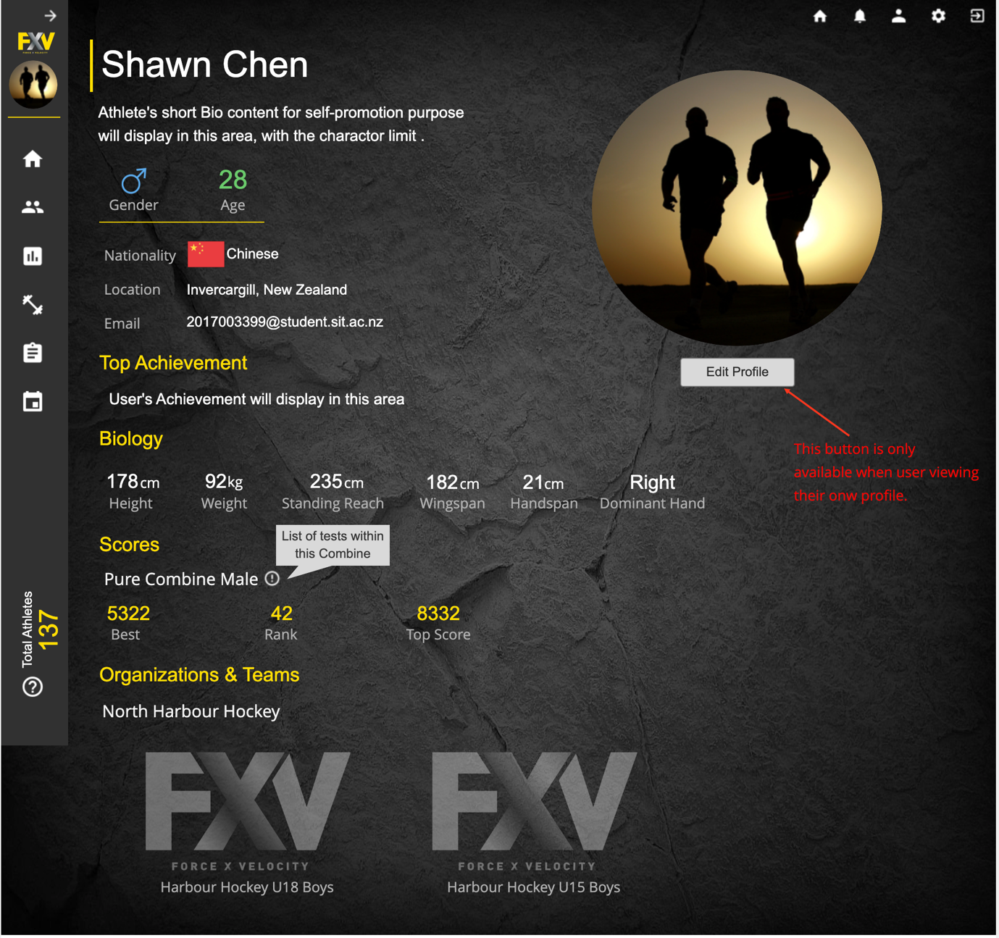

**User profile page**

**Brainstorming and experimentation**

During the re-design stage of profile page, there was an idea inspired from the design in a video game called “FIFA 18”, that to build an athlete overall ability diagram as a radar chart to show the ability and preference of a athlete, in terms of speed, agility, jump, capacity, etc...

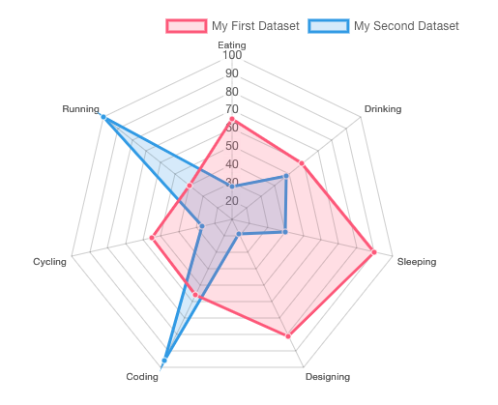

The example of Radar chart could be used in new design

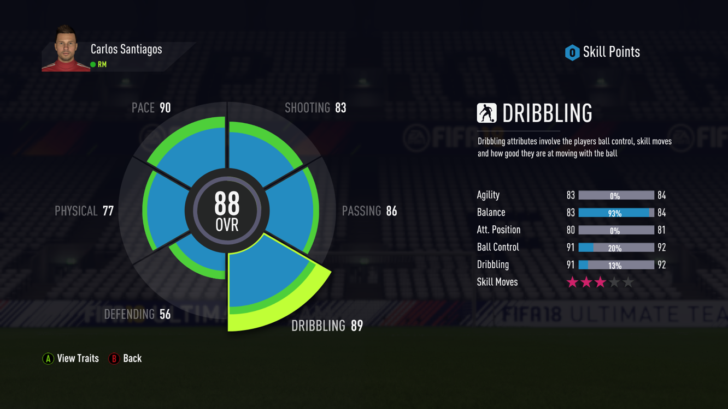

**Example of the ability chart in Video game FIFA 18**

Reference: https://images.app.goo.gl/h6UjE6YQFEYs2abm7

The purpose of this element is to show the specialization of FXV system as it is a fitness management system and to provide a fast, easy and direct way to understand current athlete's ability, especially, for the group of people like coaches and team managers.

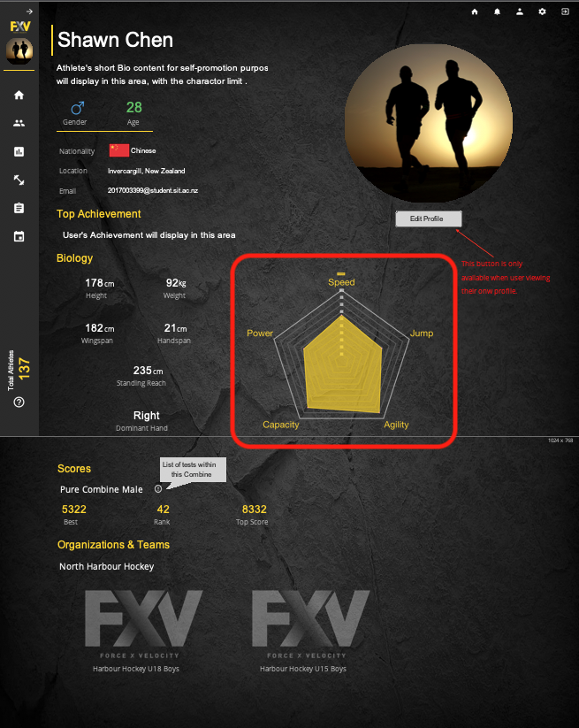

The athlete overall ability diagram was designed

However, this element was removed from the re-design of the profile page due to the shortage of research regarding to what the system users exactly expect, for example, what group of data has the top priority that need to be displayed on the diagram, and the way to analyse and calculate the data based on the collected test results. But, the athlete overall ability diagram could be possible in the future as the entire system still under the development stage.

**An overview of the information required for the application.**

In general, the FXV fitness management system consists of 3 types of information including user-based information, testing result information, and pre-set information.

* **User-based information**

The terms of user-based means the information will require application end-users to provide relevant information, like user details, team details and organization details.

* + User details are usually created by system end-users themselves during registration stage or profile editing, but system administrator also can create users with some details via bulk file import in a specific format.
  + Team information is mainly provided by a team manager or an organization manager, like team name, location, manager name, team members, team image, etc…Also, system administrators are able to create or update.
  + Organization information is provided by an organization manager or an administrator, regarding to the organization name, location, organization image, organization members, etc…
* **Testing result information**

The Testing result is mainly collected by administrator during athlete taking a test, combined test in a event. And also, it can be collected by a bulk file import function which is only available for system administrator.

* **Pre-set information**

This type of information only created by system administrators, and it will be created before the other types of users to use it. The information includes test details, combine details, and event details.

* + Test details – the details help to descript a test, and some of standard for test score calculation
  + Combine details – the details help to descript a combined test, and also define the score calculation formula cross a combination of tests.
  + Event details – the details descript an event, including the Combine used for a particular event, date & time event started, location, etc…

**An overview of how the interaction between a user and the application takes place.**

As it is a management web application, it is designed as the menu based and contains 2 main areas: navigation bar and main content area (which is used to display relevant information based on user’s execution of navigation bar).

The main reason of separating these 2 areas is because of different functions for different areas, and the user’s focus to different areas depends on their goals and intentions.

**Navigation bar**:

This area is designed to list all top-level pages to enable users to navigate through the entire system. In order to provide enough space for main content area to display information, this bar can be switched between 2 status by clicking the arrow icon on top corner of the navigation bar.

**Navigation status**:

**Extended navigation bar** – This is designed as a full version of the navigation bar and usually displayed when user just enters the home page.

**Collapsed navigation bar** – This is designed to be compressed version of the extended navigation bar. It will be displayed when either user manually switched the navigation status, user clicking on anywhere on main content area, or few seconds after the home page loaded with no further execution on navigation bar.

Both navigation status contains 3 sections:

* **Top section**:

This section consists of an FXV logo, a user profile image, and user’s name, and the profile image is clickable and used to redirect user to the profile page as same as most applications do.

* **Page links section**:

Each page link on this section is designed to act as a button directing user to different page, but the view of page links is different based on the different navigation status:

* + - Extended status: as this is the full version of navigation bar, so, this section is composed of an icon representing the action and the page name to help users to specify and perceive the possibility of action consequence based on the icon and content.
    - Collapsed status: as it is the compressed version of navigation bar, in order to give enough space to the main content area. So, the page names have removed from each page link with only icon remained, and the toast notifications are used to display page name when icon is hovered. This could also help users to specify and perceive the possibility of action consequence based on the icon and notification.

Apart of those interactions, a highlight html style applied on each page link for both navigation status when mouse hovered. This could acknowledge users that the elements are clickable and help users to identify where are they currently at the page.

* **Additional information section**:

This section has no direct interaction with users for any further action, but there is an indirect interaction between users and this section, to receive some useful information, like the number of overall system users for an administrator, the number of overall organization members for an organization manager, the number of overall team members for a team manager etc.

**Main content area**:

The application is designed in SPA (Single Page Application) mode which could allow users to interact with system with fast and responsive feedback. And the main content area is mainly used to receive further information based on user’s execution on navigation bar. And there are many different types of interaction used in this area:

* Page title – In order to help user to evaluate the actual outcomes based on their perception of expected outcomes, there is a page title on top of the main content area with a large text size.
* Content – In order to deliver information efficiently, most of information are text content with different colors and colored icons. The purpose of using different colors and colored icons within the content area, is to highlight the valuable or important information for target users, rather than always using same color for all content. This indirect interaction design could help users to be easier to focus on only useful or important information.

Apart of this, users normally could evaluate the expected outcomes based on the highlighted content on the page, this is an indirect interaction design as well.

* Icon buttons & text buttons – due to the consideration of helping users to perceive the action consequence of buttons, there are 2 types of buttons are used in this application:
  + Icon buttons – They are used for the functions which can be represented by a simple icon, like garbage icons help users to perceive the action result is to delete current item as garbage icon easily represents delete action.
  + Text buttons – used for the function cannot be easily descripted by a simple icons, like the buttons for bulk user import and bulk test result import, which require a short content to descript the function for each button. The content on the button could help users to distinguish and perceive the differences between the consequence of executing those text buttons.
* Search box – Users could directly interact with the search box by typing any content to find their expected information.